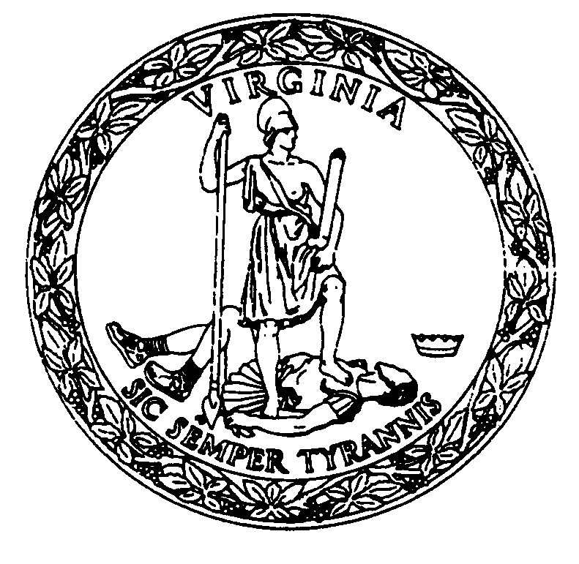
Dr. M. Norman Oliver, MD, MA
State Health Commissioner

Maisha Beasley
Director of Internal Audit

Annual audit Plan

Fiscal Year 2020
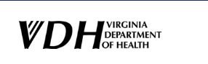
OFFICE OF INTERNAL AUDIT

INDEPENDENCE INTEGRITY EXCELLENCE
Auditor’s Letter
The Virginia Department of Health’s Office of Internal Audit is pleased to present its 2020 Audit Plan. Internal Auditing is a method designed to add value and improve VDH’s operations by utilizing a systematic and disciplined approach to evaluate the effectiveness of risk management, internal control, and governance processes.
Internal Audit provides insight into an organization’s culture, policies and procedures, and provides management oversight and monitoring. It is an invaluable way to evaluate agency performance and manage risk. Internal Auditing is not only important for ensuring our agency is compliant with information security and regulatory mandate, but it is our role to assist VDH in defining areas where it could improve, while also providing information it needs to accomplish its goals.
The mission is to provide independent, objective, and timely oversight across the VDH enterprise to assist all levels of VDH management in promoting economy, efficiency, and effectiveness in agency programs and operations that protect the health and promote the well-being of all people in Virginia and to detect and deter fraud, waste, abuse, and mismanagement.
The vision is to be an inclusive and dynamic team of professionals that serves as the catalytic change agent for process improvements.
A sound planning process is essential for the effective management of an audit organization and the proper allocation and control of resources. The Internal Audit department creates its annual audit plan based on a three-year audit cycle. The audit plan incorporates performance, financial related, and fraud detection objectives. In drafting the FY2020 audit plan, we considered previous audits already conducted based on the three-year schedule and considered input from a range of sources and people. We met with senior management to gain a better understanding of their unique operational risks and challenges.
Our goals are to deliver continuous monitoring of operations and identify emerging risks; to meet all statutory or regulatory requirements; and to strike a balance between auditing those areas of high priority and providing audit coverage of substantive operations and programs where it will have the greatest agency impact.
The work described in the audit plan aligns with the agency’s strategic goals and delivers value. If you have any questions feel free to contact me directly at maisha.beasley@vdh.virginia.gov

Maisha Beasley
Director of Internal Audit
Fiscal Year (FY) 2020 Audit Plan
Carryover Audits
There are four (4) district audits included on the FY 2019 Audit Plan that were planned and/or initiated but not completed. These audits are considered “carryover audits” and will be fully completed in FY2020:
Regional Area | District
Region 3 | Mount Rogers
Region 4 | Crater (completed July 2019)  Henrico
Region 5 | Chesapeake

Planned Health District, Office Performance, and IT Audits
Health District
The FY2020 audit plan identifies 12 district audits. These audits include economy and efficiency reviews of revenue collections and deposits, accounts receivables, and eligibility determinations, procurement, accounts payable expenditures/cash disbursements/purchase card transactions, payroll, fixed assets, budget, travel reimbursement, vehicle utilization, inventory, contracting, Cardinal reconciliation, time and effort reporting, environmental health, human resources, pharmacy, clinical, and pre-admission screenings. Some examples of the high-risk areas are:
Revenue Collections/Cash Intake
These audits will include a review of billable services and programs that earn or collect revenue for the agency to: ensure revenues are recorded accurately and in compliance with financial requirements; ensure cash receipts are recorded accurately with timely deposits; and determine if there are adequate controls over the receipt of revenue and/or cash intake activities.
Accounts Payable Expenditures/Cash Disbursements/Purchase Card Transactions
Accounts payable is an inherently high-risk activity. These audits will review the controls in place to ensure: expenditures and disbursements monitoring and oversight are in place; expenditures are proper, submitted in compliance with the Prompt Pay Act; and disbursements are allocated to appropriate activities, properly reviewed and approved prior to payment to avoid possible fraud, waste, and abuse.
Payroll
Payroll is one of the largest expenses incurred by an agency, which makes it a crucial area for audit review. There is a risk: that employees are improperly paid; duplicate or improper payments are made; and payments are not in compliance with agency and state regulatory requirements, policies, and procedures. These audits will assess if controls are in place for the payroll process and if payroll information is properly secured, accurate, and reliable.
Office Performance Audits:
The FY2020 audit plan identifies four (4) office performance audits. These are audits that include economy and efficiency and program audits. Program audits include determining the extent to which the desired results or benefits established by legislative or other authority are being achieved; the effectiveness of organizations, programs, activities, or functions; and whether the agency has complied with laws and regulations applicable to the program. Program audits may, for example:
- Assess whether the objectives of a proposed, new, or on-going program are proper, suitable, or relevant
- Determine the extent to which a program achieves a desired level of program results
- Assess the effectiveness of the program and/or of individual program components
- Identify factors inhibiting satisfactory performance
- Determine whether management has considered alternatives for carrying out the program that might yield desired results more effectively or efficiently (e.g. at a lower cost)
- Identify ways of making programs work better
- Assess the adequacy of management’s system for measuring and reporting effectiveness
IT Audits
The FY2020 audit plan identifies several applications across multiple VDH offices. These IT audits will review the controls in place for IT Network Security. The objectives of these audits will be to evaluate controls over confidentiality, integrity, and availability of VDH data processed and maintained in IT environments. We accomplish these objectives by reviewing the following areas:
- Security Management;
- Access Controls;
- Network Security;
- Configuration Management; and
- Contingency Planning
Control deficiencies put the agency at risk for compromised networks and unauthorized access. This could result in data breach, loss of protected information, and disruption to operations as well as a negatively impacted image and reputation of VDH.

Fiscal Year 2020 VDH Internal Audit Plan
Health Districts:
Region 1  Central Shenandoah  Thomas Jefferson | Region 2  Loudoun | Region 3  Cumberland Plateau  West Piedmont  Pittsylvania/Danville | Region 4  Piedmont  Southside  Chesterfield | Region 5  Three Rivers  Hampton  Peninsula

Administration:
Agency Risk Management and Internal Controls
Office of Financial Management

Office of the Commissioner:
Vital Records

Population Health:
Office of Epidemiology – Division of Pharmacy Services (Carryover from FY19 Plan)
Public Health:
Office of Emergency Preparedness
Information Management and Sensitive Systems:
OEMS – WIPS (Planning for possible audit)
OEPI – X-Ray Registrant
OEPI – ESSENCE, VEDSS, REDCap
OFHS – CCC-SUN, LISSDEP, Docushare
OIM – Data Warehouse, HP Quality Center
OEMS – Image Trend,
OEPI – EHARS, LMS, Maven, Record RX, VCS,

Internal Audit Administration:
Coordinate the APA Audit and Management Corrective Action Plan
Coordinate the OSIG Performance Review
Investigate Hotline Complaints as directed by OSIG
Perform Special Projects requested by Management
Perform Follow-up Reviews of Prior Year Audits
Perform the OIA Quality Assurance Self-Assessment
Coordinate Audit & Risk Advisory Committee Meetings

Prepared by: Approved by:
OIA-Maisha Beasley, Director Norman Oliver, MD, State Health Commissioner
Date: Date:

