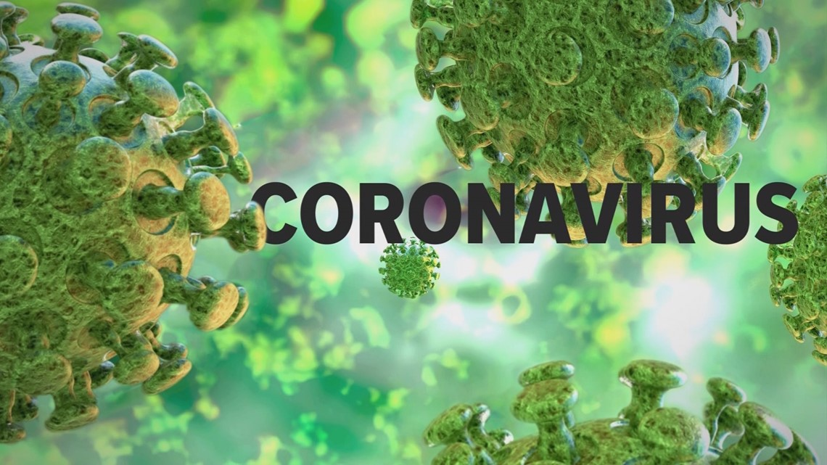
Three Rivers Health District and the Virginia Department of Health are closely monitoring an outbreak of a respiratory illness caused by a novel (new) coronavirus (termed "COVID-19") that was first detected in Wuhan City, China and reported in December 2019. Infections with COVID-19 are being reported in a growing number of countries across the world, and in an increasing number of locations in the United States. For the latest information and updates, please click here.

