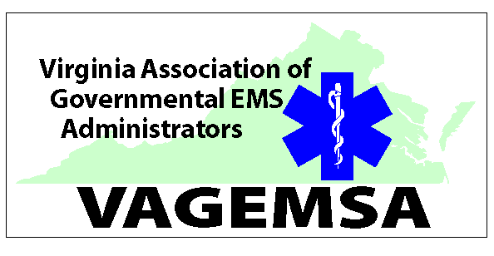
VAGEMSA Meeting August 5, 2016, Courtyard by Marriott, Glen Allen, VA
President Eddie Ferguson called the meeting to order at 10:30 hours at the Courtyard by Marriott, Glen Allen, VA. President Ferguson welcomed everyone to the meeting, led the group in a moment of silence for fallen firefighters and EMS providers. He then led recitation of the Pledge of Allegiance. Introduction of Attendees followed.
Minutes of the May meeting were corrected and approved.
Officer Reports:
- President’s Report – Eddie Ferguson thanked all for their attendance, recruitment efforts and dues collection. FY 17 invoices are out.
Executive committee met by phone and discussed the legislative session and training fund changes. Committee recognized the successes with line of duty and LODD. Discussed Mobile Integrated Healthcare. A follow-up meeting was rained out.
The president attended the LODD and REPLICA bill signing. In addition VAGEMSA was represented at two legislative stakeholders meetings promoting the top EMS legislative issues. We were also charged to work together various stakeholders to develop a coordinated list of public safety initiatives so that continuity among agencies in legislative requests. We continue to sponsor training at VFCA conference and Officer Academy. We have been asked to sponsor classes at the 2017 VFCA Conference. We are pursuing several opportunities. Any suggestions please forward to President Ferguson. Congratulations to all agencies who earned Mission Lifeline awards.

- Treasurer’s report – Ray Whatley submitted the treasurer’s report for the period from May 1, 2016 to August 1, 2016, that was read by the secretary. Receipts were $3,190.76; Expenditures were $2,287.50, leaving a balance, as of August 1st, of $903.26.

- Other Officer’s Reports
Reminder to attend GAB at 1 p.m. today.
- OEMS Reports
Warren Short – CE transition completed. New CE scanners coming out with easier use and greater flexibility. Testing at Symposium. Symposium registrations are open and a call for presentations to the 2017 symposium is out. Regs regarding training coming soon please review.
Adam Harrell - Regarding EMS Training funds old process is no longer usable. Looking to create MOUs with Regional Councils. Discussion was held regarding possible plan options.
- Lobbyist’s Report – Ed Rhoades
Ed and leadership has attended several meetings recently regarding personnel FOIA inquiries, funding recovery from General Fund, Fire Program Bill and Fire Prevention code. Ed attended a meeting regarding mental health for EMS and the fire service.
- Old Business:
  - Chief Critzer discussed Active Threat / Shooter and the need to share our best practices. Some discussion from the group regarding provider health and safety.
  - President Ferguson mentioned the ongoing work on the website.

- New Business:
- Requested and named a nominating committee. They are Brian Hricik (chair), Larry Oliver and Lori Knowles.
- Dennis Hale discussed the 911 Services Board. For more information feel free to contact him.
- A motion was made and passed to provide a $500 donation to support symposium.
- Workgroup assignments. Education Coordinator workgroup Brian MacIntosh, Ray Whatley and Suzanne Helbert. Assess accredited Psychomotor assessment options Robin Smith.

- Committee Reports: (More detailed reports can be found in the EMS Quarterly Report booklet found on line at the VA OEMS web site)

A special presentation titled “The Profile of Wounding in Civilian Public Mass Shooting Fatalities” presented by Babak Sarani, MD, FACS, FCCM
Next meeting will be on 11/10/2016 at Symposium. Meeting was adjourned at 11:53.

